FYP Proposal

Self-Balance Reuleaux Triangle

1. Objective

It is a project proposal based on an open source project of a self-balancing reuleaux triangle from the source owner “45555jun”. The objective of the project is to perform an unstable equilibrium system with aid of the control system.

*Demonstrating Video:* [*https://www.bilibili.com/video/BV14a411q7EF*](https://www.bilibili.com/video/BV14a411q7EF)

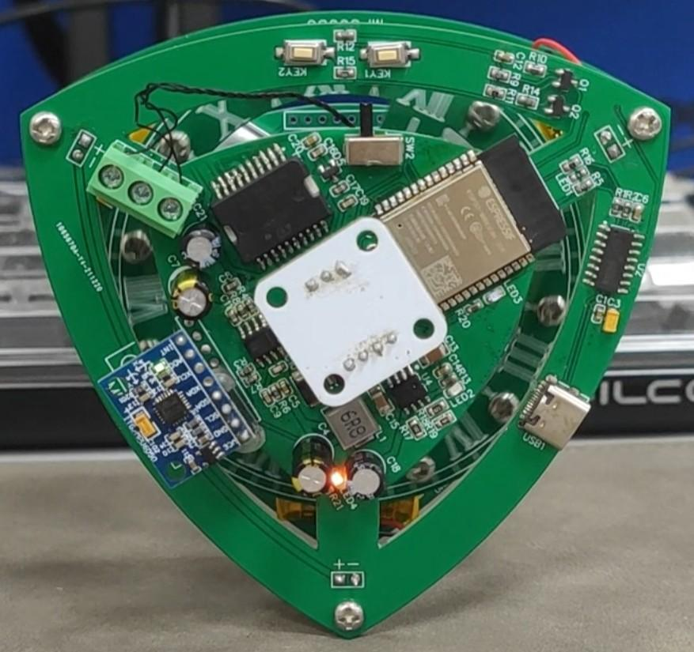

1. Procedures
   1. PCB Design
      1. Apperance

To ease the rotation of the system, the reuleaux triangle is used in the design, to minimize the force required for the system.

* + 1. MCU

Arduino/ESP series MCUs are preferred.

Arduino has a well-developed library for implementing this project.

ESP series provide wireless features including wireless programming, control, and system monitoring, and a relatively high compatibility with arduino library.

* + 1. Sensors

To monitor the state (angle of rotation) of the system, accelerometers are considered to be used to detect the tilt angle.

* + 1. Motor

To provide enough rotational force for the system, the momentum wheel is considered to be used to provide the required force.

* + 1. Charging Circuit (Optional)

To prevent wires from affecting the mobility of the system. Power supply is better to be embedded into the system.

* 1. Control System

To enhance the performance for the system, different control systems will be tested on maintaining the unstable equilibrium system.

* 1. Calibratio

To tune the system, collect and interpret data extracted from the system, and make improvements on the system.

1. Research Fields
   1. PCB Designing

Designing a workable PCB and implementing it on a workable product.

* 1. MCU

System control and monitoring via MCUs

* 1. Control System

Researching on how different control systems (e.g. PID, LQR, *MPC*) act differently on this system, studying improvements and optimizations can be performed on the system based on the data extracted.